A B O U T
I am a highly motivated and dedicated student looking for the first formal work experience.
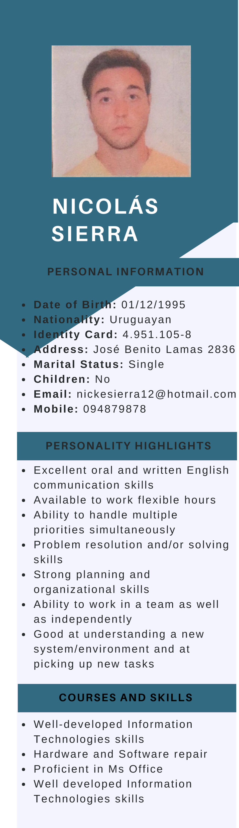
Personable and astute academic with proven learning, communication and time management abilities developed from being an active medicine student and Surgical Assistant. Strong interpersonal and collaboration skills enhanced by sporting as a semi-professional tennis player. By taking part in my family's business I have obtained knowledge in the area of seamanship, and additionally, an understanding of general employability skills and the importance of working as part of a team, learning from others and developing as a professional.
E D U C A T I O N

Facultad de Medicina, Universidad de la República,
Montevideo | 2014 - Current
Facultad de Psicología, Universidad de la República,
Montevideo | 2018 - Current
HIGH SCHOOL AND PRIMARY SCHOOL
Instituto Geselliano, Montevideo | 2001 - 2010
Pocitos Day School, Montevideo | 2011 - 2012
P R O F E S S I O N A L / P E R S O N A L R E F E R E N C E S

Daniel Piven
FAIRPLAY Group SRL (Wilson Tennis Uruguay)
Contact: 099195066
Ignacio González
Director in González Conde Construcciones
Contact: 098919550

